**1D ARRAYS**Q. Create an array of length 10 of integers. Values ranging from 1 to 50.1. Find all pair of elements whose sum is 25.

**SOLUTION:**

int[] arr = new int [10];

Console.WriteLine("Range of Element in Array is 1-50\n :");

for (int i = 0; i < arr.Length; i++)

{

Console.Write("Enter Element at index {0} : ",i+1);

arr[i] = int.Parse(Console.ReadLine());

}

Console.WriteLine("\n");

int count = 0;

for (int j = 0; j < arr.Length; j++)

{

for (int k = (j+1); k < arr.Length-1; k++)

{

if ((arr[j]+arr[k])==25)

{

Console.WriteLine("SUm of 25 is Found at Index {0} and {1} ",j+1,k+1);

count++;

}

}

}

if (count==0)

{

Console.WriteLine("no elements found whose sum is 25");

}

Console.ReadLine();

**OUTPUT:**

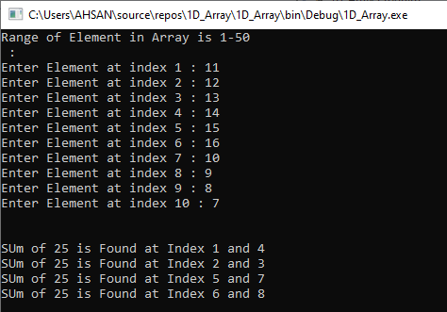

2. Find the number of elements of A which are even, and the number of elements of A which are odd.

**SOLUTION:**

int[] arr = new int [5];

Console.WriteLine("Range of Element in Array are 1-50 :");

for (int i = 0; i < arr.Length; i++)

{

Console.Write("Enter Element : ");

int a = int.Parse(Console.ReadLine());

if (arr[i]<1||arr[i]>50)

{

Console.WriteLine("Out of Bound--");

}

if (a % 2 == 0)

{

Console.WriteLine(" No are Even");

}

else

{

Console.WriteLine(" No are Odd");

}

}Console.ReadLine();

**OUTPUT:**

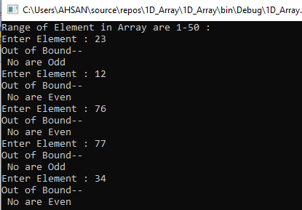

3. Write a procedure which finds the average of the value of A**SOLUTION:**

int sum = 0;

Console.Write("Enter size of array : ");

int n = int.Parse(Console.ReadLine());

int[] arr = new int[n];

Console.WriteLine("Enter values: ");

for (int i = 0; i < n; i++)

{

arr[i] = int.Parse(Console.ReadLine());

sum += arr[i];

}

Console.WriteLine("AVERAGE : "+(sum/arr.Length));

**OUTPUT:**

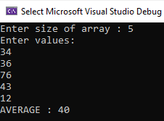

**2D ARRAYS**

1. Write a program which input 2 matrix of user defined rows and columns and perform following operation **a. Display / Print as a Matrix b. Addition of Matrix c. Subtraction of Matrix**

**d. matrix multiplication**

**SOLUTION:**

int a, b, i, j, m, n, x, y;

Console.Write("enter no of rows: ");

int row = int.Parse(Console.ReadLine());

Console.Write("enter no of cols: ");

int col = int.Parse(Console.ReadLine());

int[,] matrix = new int[row, col];

for (i = 0; i < row; i++)

{

for (j = 0; j < col; j++)

{

Console.Write("matrix[{0},{1}]= ", i, j);

matrix[i, j] = int.Parse(Console.ReadLine());

}

}

Console.WriteLine();

for (i = 0; i < row; i++)

{

for (j = 0; j < col; j++)

{

Console.Write(" " + matrix[i, j]);

}

Console.WriteLine();

}

Console.Write("\n\nenter no of rows for matrix 2: ");

int row1 = int.Parse(Console.ReadLine());

Console.Write("enter no of cols for matrix 2: ");

int col1 = int.Parse(Console.ReadLine());

int[,] matrix1 = new int[row, col];

for (a = 0; a < row1; a++)

{

for (b = 0; b < col1; b++)

{

Console.Write("matrix1[{0},{1}]= ", a, b);

matrix1[a, b] = int.Parse(Console.ReadLine());

}

}

Console.WriteLine();

for (i = 0; i < row1; i++)

{

for (j = 0; j < col1; j++)

{

Console.Write(" " + matrix1[i, j]);

}

Console.WriteLine();

}

m = matrix.GetLength(0);

n = matrix.GetLength(1);

Console.WriteLine(" \t SUM OF MATRIX ");

int[,] sum = new int[m, n];

for (x = 0; x < m; x++)

{

for (y = 0; y < n; y++)

{

sum[x, y] = matrix[x, y] + matrix1[x, y];

Console.Write(" " + sum[x, y]);

}

Console.WriteLine();

}

Console.WriteLine(" \n\t SUBTRACT OF MATRIX ");

int[,] sub = new int[m, n];

for (x = 0; x < m; x++)

{

for (y = 0; y < n; y++)

{

sub[x, y] = matrix[x, y] - matrix1[x, y];

Console.Write(" " + sub[x, y]);

}

Console.WriteLine();

}

Console.WriteLine(" \n\t MULTIPLY OF MATRIX ");

int[,] mul = new int[m, n];

for (x = 0; x < m; x++)

{

for (y = 0; y < n; y++)

{

mul[x, y] = matrix[x, y] * matrix1[x, y];

Console.Write(" " + mul[x, y]);

}

Console.WriteLine();

}

**OUTPUT:** 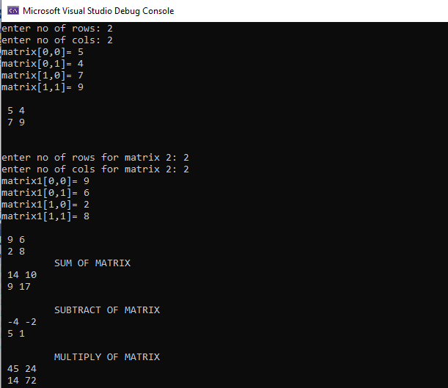

**e. Determinant**

**f. Inverse**

**SOLUTION:**

int a, b, i, j;

Console.Write("enter no of rows: ");

int row = int.Parse(Console.ReadLine());

Console.Write("enter no of cols: ");

int col = int.Parse(Console.ReadLine());

int[,] matrix = new int[row, col];

for (i = 0; i < row; i++)

{

for (j = 0; j < col; j++)

{

Console.Write("matrix[{0},{1}]= ", i, j);

matrix[i, j] = int.Parse(Console.ReadLine());

}

}

Console.WriteLine();

for (i = 0; i < row; i++)

{

for (j = 0; j < col; j++)

{

Console.Write(" " + matrix[i, j]);

}

Console.WriteLine();

}

Console.WriteLine("\n \t DETERMINANT OF MATRIX");

a = matrix[0, 0] * matrix[1, 1];

b = matrix[0, 1] * matrix[1, 0];

int det = a - b;

Console.WriteLine("\n DETERMINANT : " + det);

Console.WriteLine("\n \t ADJOINT OF MATRIX");

int temp;

temp = matrix[0, 0];

matrix[0, 0] = matrix[1, 1];

matrix[1, 1] = temp;

matrix[0, 1] *= -1;

matrix[1, 0] *= -1;

for (i = 0; i < row; i++)

{

for (j = 0; j < col; j++)

{

Console.Write(" " + matrix[i, j]);

}

Console.WriteLine();

}

Console.WriteLine("\n\t INVERSE of MATRIX : ");

for (i = 0; i < row; i++)

{

for (j = 0; j < col; j++)

{

float d = matrix[i, j];

float res = d / det;

Console.Write(" " + res);

}

Console.WriteLine();

}

**OUTPUT:**

